Threaded Binary Trees

In the linked representation of binary trees, more than one half of the link fields contain NULL values which results in wastage of storage space. If a binary tree consists of **n** nodes then **n+1** link fields contain NULL values. So in order to effectively manage the space, a method was devised by Perlis and Thornton in which the NULL links are replaced with special links known as threads. Such binary trees with threads are known as **threaded binary trees**. Each node in a threaded binary tree either contains a link to its child node or thread to other nodes in the tree.

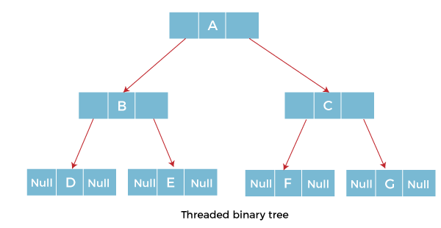

### **Types of Threaded Binary Tree**

There are two types of threaded Binary Tree:

* One-way threaded Binary Tree
* Two-way threaded Binary Tree

**One-way threaded Binary trees:**

In one-way threaded binary trees, a thread will appear either in the right or left link field of a node. If it appears in the right link field of a node then it will point to the next node that will appear on performing in order traversal. Such trees are called **Right threaded binary trees**. If thread appears in the left field of a node then it will point to the nodes inorder predecessor. Such trees are called **Left threaded binary trees.** L

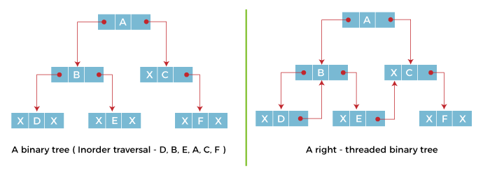

**Two-way threaded Binary Trees:**

In two-way threaded Binary trees, the right link field of a node containing NULL values is replaced by a thread that points to nodes inorder successor and left field of a node containing NULL values is replaced by a thread that points to nodes inorder predecessor.

